Maths Key Skills Stage 2: Skill Check 8

Name: ___________________________________ Date: _______________ Class/Group: _______________________________

A: Place Value, Add and Subtract |  | B: Multiply, Divide and Fractions |  |  | C: Measure and Geometry
1. What is the missing number?  0 5 10 20 25 | 2:1 | 11. 9 x 10 = |  | 2:11 | 21. What units would you use to measure the length of a pencil?  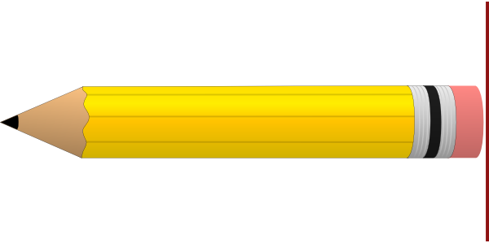  a. centimetres  b. grams  c. millimetres |  | 2:17
2. What is the value of the 6 in this number? 61 | 2:2 | 12. 14 ÷ 2 = |  | 2:11 |  |  | 2:17
3. Estimate the number labelled.  0  20  10 | 2:3 | 13. What symbol is missing?  24 ÷ 6 4 |  | 2:12 | 22. How many edges does a cube have?  a. 6  b. 8  c. 12 |  | 2:24
4. Use <, > or = to make this correct:  21 32 | 2:4 | 14. What symbol is missing?  4 8 = 32 |  | 2:12 |  |  | 2:24
5. Write this number in numerals.  seventy eight | 2:5 | 15. Tick (✓) if true:  5 x 6 = 6 x 5 30 ÷ 3 = 3 ÷ 30 |  | 2:13 | 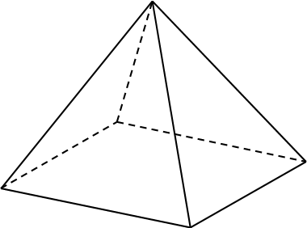  23. Name the shaded face on this pyramid. |  | 2:25
6. There are 25 sweets in a bag. Tom eats 17 of them. How many are left? | 2:6 | 16. £15 is shared between 3 people. How much does each person get? |  | 2:14 |  |  | 2:25
7. 12 + = 20 | 2:7 | 17. 4 cars each have 3 people in them. How many people are in the cars? |  | 2:14 | 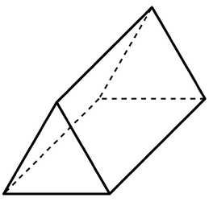  24. Tick (✓) the shape that does not have 5 faces. |  | 2:26
8. 47 - 24 = | 2:8 | 18. Circle two thirds  of the strawberries.  2  3 |  | 2:15 |  |  | 2:26
9. Is this true? Write ‘yes’ or ‘no’.  29 - 12 = 12 - 29 | 2:9 | 19. Shade in  3  4  of the shape. |  | 2:15 | 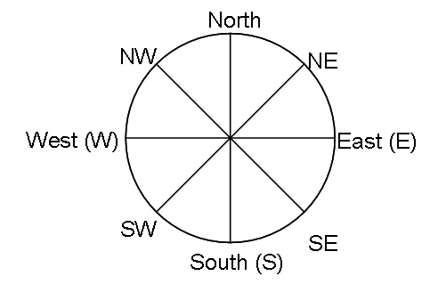  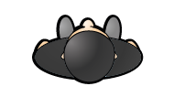  25. Ben is facing North.  What direction will  he be facing after  turning through 3  right-angles clockwise? |  | 2:28
10. Use 29 + 32 = 61 to help find:  61 - 32 = | 2:10 | 20. What is of 12 ? |  | 2:16 |  |  | 2:28
Total (A) |  | Total (B) |  |  | Total (C)
Test Total (A+B+C) |  | R (0-9) | Y (10-19) |  |  | G (20-25)

