Maths Key Skills Stage 3: Skill Check 1

Name: ___________________________________ Date: _______________ Class/Group: _______________________________

A: Place Value, Add and Subtract |  | B: Multiply, Divide and Fractions |  |  | C: Measure and Problem Solving
1. What is the missing number?  0 8 12 16 | 3:1 | 11. 36 ÷ 4 = |  | 3:10 | 23. How many centimetres are in one and a half metres? |  | 3:19
2. What is the 8 worth in this number?  183 | 3:2 | 12. 8 x 8 = |  | 3:10 |  |  | 3:19
3. Write this number in numerals.  two hundred and fifty | 3:3 | 13. Use 12 x 3 = 36 to solve:  24 x 3 = |  | 3:11 | 22. The sides of a square are 4cm.  What is the perimeter  of the square? |  | 3:20
4. What number is labelled?  0  40 | 3:4 | 14. What is the missing number?  7 x = 82 - 12 |  | 3:12 |  |  | 3:20
5. Make the largest number possible using the digits 2 7 5. | 3:5 | 15. What is the missing number?  0.7 0.8 0.9 1.1  2  10 |  | 3:13 |   23. I had £1. I bought  2 cartons of drink  and got 30p change.  How much did each  carton of drink cost? |  | 3:21
6. 890 + 10 = | 3:6 | 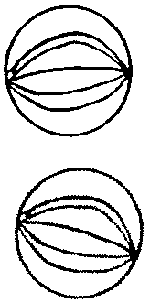  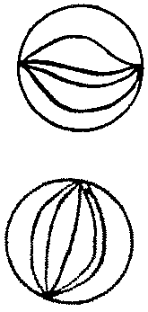  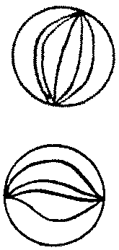  16. Circle  of the marbles.  1  3 |  | 3:14 |  |  | 3:21
7. 436 - 123 = | 3:7 | 17. What is of 12? |  | 3:15 | 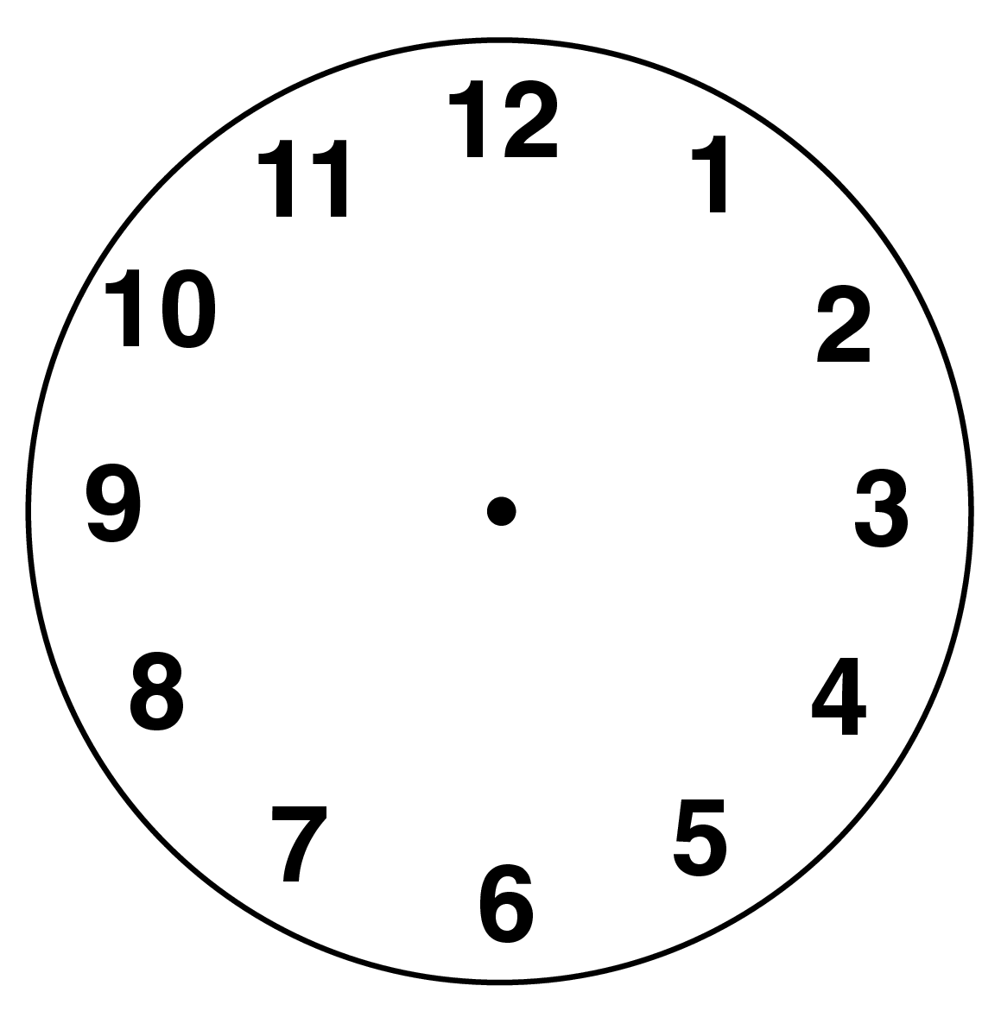  24. Draw the hands  to show  five minutes  past four o’ clock |  | 3:22
8. Circle the best estimate to 59 + 39:  80 90 100 110 | 3:8 | 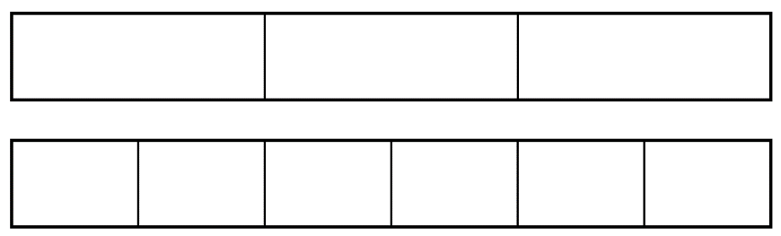  18.  2  6  ?  3  = |  | 3:16 |  |  | 3:22
9. One orange costs nineteen pence. How much will three oranges cost? | 3:9 | 19. Add the  2  5  1  5  +  fractions. |  | 3:17 | 25. How many seconds are in two minutes? |  | 3:24
10. What is the missing number?  - 19 = 13 | 3:9 | 20. Write the  1  5  1  6  1  4  1  2  largest fraction. |  | 3:18 |  |  | 3:24
Total (A) |  | Total (B) |  |  | Total (C)
Test Total (A+B+C) |  | R (0-9) | Y (10-19) |  |  | G (20-25)

