**Stage 5**

**PROMPT sheet**

**5/1 Place value in numbers to 1million**

The position of the digit gives its size

|  |  |  |  |  |  |  |
| --- | --- | --- | --- | --- | --- | --- |
| Millions | Hundred thousands | Ten thousands | thousands | hundreds | tens | units |
| **1** | **2** | **3** | **4** | **5** | **6** | **7** |

Example

The value of the digit ‘**1**’ is **1** 000 000

The value of the digit ‘**2**’ is **2**00 000

The value of the digit ‘**3**’ is **3**0 000

The value of the digit ‘**4**’ is **4**000

**5/2 Round numbers to nearest 10, 100,**

**1000, 10000, 100000**

**Example** 1– Round 3**42** 679 to the nearest 10 000

* Step 1 – Find the ‘round-off digit’ - **4**
* Step 2 – Look one digit to the right of 4 - **2**

5 or more? NO – leave ‘round off digit’ unchanged

- Replace following digits with zeros

ANSWER – 3**4**0 000

**Example** 2– Round **45**3 679 to the nearest 100 000

* Step 1 – Find the ‘round-off digit’ - **4**
* Step 2 – Look one digit to the right - **5**

5 or more? YES – add one to ‘round off digit’

- Replace following digits with zeros

ANSWER – **5**00 000

**5/3 Negative numbers**

A number line is very useful for negative numbers.

* The number line below shows:

**4** – 7 = **-3**

l l l l l l l l l

-3 -2 -1 0 1 2 3 4 5

* The number line below shows:

**-2** + 6 = **4**

l l l l l l l l l

-3 -2 -1 0 1 2 3 4 5

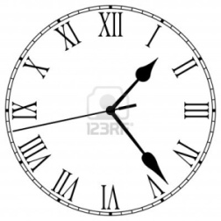

**5/4 Roman Numerals**

The seven main symbols   
  
I = 1  
V = 5  
X = 10  
L = 50  
C = 100  
D = 500  
M = 1000

Other useful ones include:

IV = 4

IX = 9

XL = 40

XC = 90

**5/5 Written methods for addition**

* **Line up the digits in the correct columns**
* **Start from RIGHT to LEFT**

e.g. 48 + 284 + 9 H T U

4 8

2 8 4

1 2 9 +

3 4 1

**5/5 Written methods for subtraction**

* **Line up the digits in the correct columns**
* **Start from RIGHT to LEFT**

e.g. 645 - 427 H T U

6 34 15

4 2 7 -

2 1 8

**5/6 Mental methods for addition**

* **Start from LEFT to RIGHT**

Example 1 – think of:

**45** + **3**2 as **45** + **3**0 + 2

* But in your head say:

**45 75 77**

Example 2 – think of:

**1236** + **415** as **1236** + **400** + **10** + 5

* But in your head say:

**1236 1636 1646 1651**

**5/6 Mental methods for subtraction**

Example 1 – think of:

**56** – **3**2 as **56** – **30** – 2

* But in your head say:

**56 26 24**

Example 2 – think of:

**1236** - **415** as **1236** - **400** - **10** - 5

* But in your head say:

**1236 836 826 821**

**5/7 Multi-step problems**

**Based upon 5/6.**

**Words associated with addition:**

total

sum

altogether

add

Words associated with subtraction:

difference

Subtract

minus

How many more?

**5/8 Multiples & factors**

* **FACTORS** are what divides exactly into a number

e.g. Factors of 12 are: Factors of 18 are:

1 12 1 18

2 6 2 9

3 4 3 6

The common factors of 12 & 18 are: 1, 2, 3, 6,

The Highest Common Factor is: 6

* **MULTIPLES** are the times table answers

e.g. Multiples of 5 are: Multiples of 4 are:

5 10 15 **20**  25 ...... 4 8 12 16  **20** .......

The Lowest Common Multiple of 5 and 4 is: **20**

**5/9 Prime numbers**

**Prime numbers have only TWO factors**

The factors of 12 are: Factors of 7 are:

**1, 2, 3, 4, 6, 12 1, 7**

**12 is NOT prime 7 IS prime**

**It is composite**

**Prime numbers to 20**

|  |  |  |  |  |
| --- | --- | --- | --- | --- |
| 1 | **2** | **3** | 4 | **5** |
| 6 | **7** | 8 | 9 | 10 |
| **11** | 12 | **13** | 14 | 15 |
| 16 | **17** | 18 | **19** | 20 |

**The number ‘1’ is NOT prime**

It has only ONE factor

**5/10 Multiplication using a formal method**

* **By a ONE-DIGIT number**

e.g. 3561 x 7 **COLUMN METHOD**

3561

7x

24927

3 4

e.g. 3561 x 7  **GRID METHOD**

|  |  |  |  |  |
| --- | --- | --- | --- | --- |
|  | 3000 | 500 | 60 | 7 |
| 7 | 21000 | 3500 | 420 | 49 |

21000 + 3500 + 420 + 49 = 24927

* **By a TWO-DIGIT number**

e.g. 152 x 34 **COLUMN METHOD**

152

34x

608 (x4)

4560 (x30)

**5168**

e.g. 152 x 34 **GRID METHOD**

|  |  |  |  |
| --- | --- | --- | --- |
|  | 100 | 50 | 2 |
| 30 | **3000** | **1500** | **60** |
| 4 | **400** | **200** | **8** |

152 x 34 = 3400 + 1700 + 68 = **5168**

**5/10 Division using a formal method**

* **By a ONE-DIGIT number**

e.g. 9138 ÷ 6 1 5 2 6

6 )9311318

* **By a TWO-DIGIT number**

e.g. 4928 ÷ 32 **SAME METHOD**

(Except write down some of your tables down first)

32

64 0 1 5 4

96 32 449172 128

128

160

4928 ÷ 32 = **154**

e.g. 4928 ÷ 32 **ALTERNATE METHOD**

* Divide
* Multiply
* Subtract
* Bring down - Make a new number
* Divide ...

0 1 5 4

32 4 9 2 8

-3 2

1 7 2

-1 6 0

1 2 8

-1 2 8

0 0 0

4928 ÷ 32 = **154**

**5/11 Multiply & divide by 10, 100, 1000**

* **By moving the decimal point**

To **multiply** by 10 move the dp ONE place RIGHT

e.g. 13 X 10 = 130

3.4 x 10 = 34

To **divide** by 10 move the dp ONE place LEFT

e.g. 1 3 ÷ 10 = 1.3

3.4 ÷ 10 = 0.34

* **By moving the digits**

To multiply by 10 move the digits ONE place LEFT

e.g. 3.52 x 10

= 3 5 . 2

To multiply or divide by 100 move TWO places

To multiply or divide by 1000 move THREE places

**5/12 Square & Cube numbers**

Square numbers

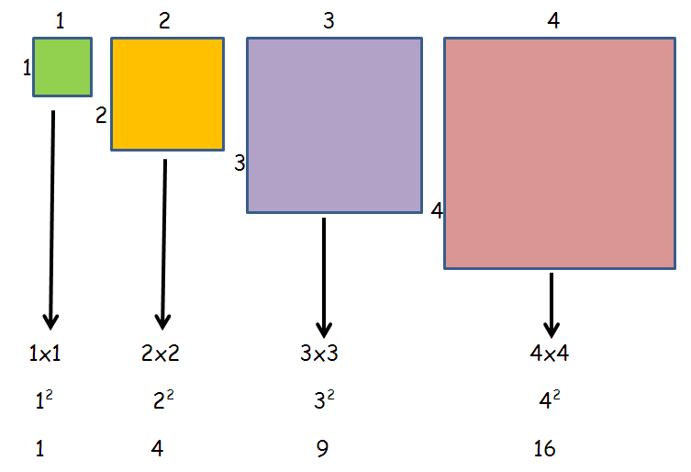

Cube numbers

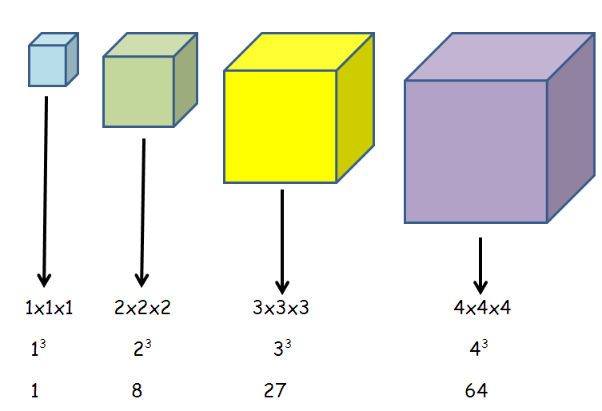

**5/13 Fractions**

* To compare fractions

– the denominators must be the same



 and 

 and 

SO  is bigger than 

* To add and subtract fractions

**When the denominators are the same**

 +  = 

Do not add

the denominators

 -  = 

Do not subtract

the denominators

**5/13 To add subtract fractions (cont)**

**When the denominators are different**

 + 

(x2)

(x2)

Multiply to make the denominators the same

 +  = 

**5/14 Equivalent fractions**

These fractions are the same but can be

drawn and written in different ways

|  |  |
| --- | --- |
|  | = |
|  |  |

 = 

 = 

(x4)

(x4)

Fractions can also be divided to make the fraction look simpler – this is called CANCELLING or LOWEST FORM

 = 

(÷4)

(÷4)

**5/15 Mixed & improper fractions**

* **An improper fraction is top heavy**

**& can be changed into a mixed number**

 can be shown in a diagram

1 ½

 = 1½

Improper fraction Mixed number

* **A mixed number can be changed back into an improper fraction**

1½ = 

2¾ = 

**5/16 Multiply fractions**

Multiply is the same as repeated addition

|  |  |
| --- | --- |
|  | +  + |
|  |  |

 ­ +  + 

 x 3 =  ­ +  +  =  = 2

OR

 x  =  = 2

**5/17 Round decimals**

Rules for rounding

1. **Find the ‘round off’ digit**
2. **Move one digit to its right**
3. **Is this digit 5 or more**

Yes – add one to the round off digit

No – don’t change the round off digit

* **To the nearest whole number**

e.g. 1 – To round **5**.**6**2 to the nearest whole

**‘round off’ digit** **this digit is 5 or more**

5.62 rounded to nearest whole = 6

e.g. 2 – To round **5**.**3**2 to the nearest whole

**‘round off’ digit** **this digit is NOT 5 or more**

5.32 rounded to nearest whole = 5

* **To one decimal place**

e.g. 1 – To round 12.**37** to 1 decimal place

**‘round off’ digit** **this digit is 5 or more**

12.37 rounded to 1dp = 12.4

e.g. 2 – To round 12.**32** to the nearest whole

**‘round off’ digit** **this digit is NOT 5or more**

12.37 rounded to 1dp = 12.3

**5/18 Read & write decimals**

The value of each digit is shown in the table

|  |  |  |  |  |  |  |
| --- | --- | --- | --- | --- | --- | --- |
| hundreds | tens | units |  | tenths | hundredths | thousandths |
| 3 | 5 | 2 |  | 6 | 1 | 7 |
| 300 | 50 | 2 |  |  |  |  |
| 352 | | |  |  | |  |
| 352 | | |  |  | | |

**5/18 Order decimals**

Example – To order 0.28, 0.3, 0.216

* Write them under each other
* **Fill gaps with zeros**
* Then order them

0.28 0.28**0**

0.3 0.3**00**

0.216 0.216

smallest largest

Order: 0.216 0.28 0.3

**5/19 Decimal & Percentage equivalents**

**Learn**

|  |  |  |
| --- | --- | --- |
| Fraction | Decimal | Percentage |
|  | 0.5 | 50% |
|  | 0.25 | 25% |
|  | 0.2 | 20% |
|  | 0.1 | 10% |
|  | 0.01 | 1% |

Some fractions have to be changed to be ‘out of 100’

(x4)

 =  = 0.44 = 44%

(x4)

**5/20 Convert metric measure**

* **Length**

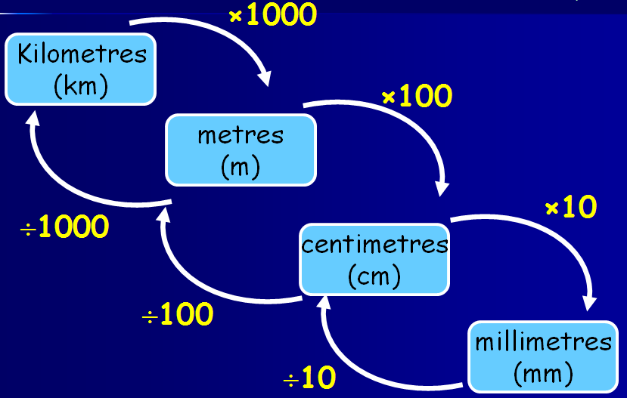

* **Mass or weight**

grams

(g)

kilograms

(kg)

**÷1000**

**x1000**

* **Capacity or volume**

millilitres

(ml)

litres

(l)

**x1000**

**÷1000**

**5/20 Imperial measure**

* 1 inch is about 2.5cm

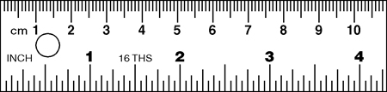

* 1km = 1.6 miles or 5miles = 8km



* 1kg is about 2.2pounds

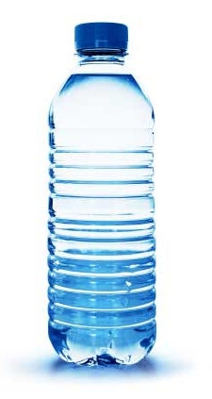

* A litres of water’s a pint and three quarters
* 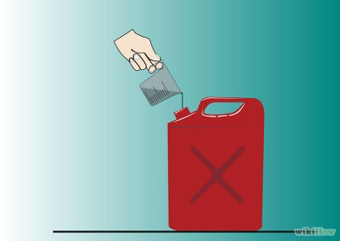A gallon is about 4.5 litres

**5/21 Area & Perimeter**

* **Estimate area**

|  |  |  |  |  |  |  |  |
| --- | --- | --- | --- | --- | --- | --- | --- |
|  |  |  |  |  |  |  |  |
|  |  |  |  |  |  |  |  |
|  |  |  |  |  |  |  |  |
|  |  |  |  |  |  |  |  |
|  |  |  |  |  |  |  |  |
|  |  |  |  |  |  |  |  |

Number of whole squares( ) = 16

Number of ½ or more ( ) = 5

Estimated area = 21 squares

* **Shapes composed of rectangles**

Put on all missing lengths first

For perimeter – ADD all lengths round outside

For area - split into rectangles & add them together

12cm

4cm 6cm

8cm

12cm

4cm 6cm

8cm

2cm

4cm

Perimeter = 12 + 6 + 4 + 2 + 8 + 4 = 36cm

12cm

A

4cm 6cm

B

8cm

2cm

4cm

Area of shape = Area of A + B

= (8x4) + (6x4)

= 32 + 24

= 56cm2

**5/22 Volume**

Volume is measured in cubes

**The 1 cm cube**

|  |
| --- |
| 1cm  The volume of this cube is 1 cm³  (1 cubic centimetre)  **It holds 1ml of water**  1cm  1cm |

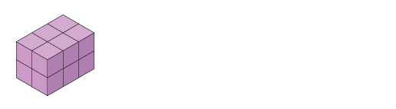

This cuboid contains 12 cubes

So the volume is 12 cm³



This 3D shape contains 12 cubes

So the volume is 12 cm³

**5/23 Units of time**

* **Time conversion**

x365

days

year

x24

÷365

x60

hours

÷24

x60

min

÷60

sec

÷60

* **Time intervals**

Always go to the next whole hour first

Example: 0830 to 1125

30min + 2h 25min = 2h 55min

0830 0900 1125

**5/24 2D representations of 3D shapes**

* There are 3 views:

**Plan view**

**Side elevation**

**Front elevation**

**5/25 Angles**

* **Types of angles**

Acute Obtuse

(less than 900) (Between 900 & 1800)

Reflex

(Between 1800 & 3600)

* **Measure and draw angles**

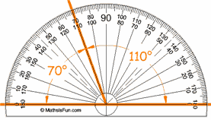

To be sure, count the number of degrees between the two arms of the angle

**5/26 Angles**

Angles on a straight line add up to 1800

or 2 right angles (2 x 900)

Angles about a point add up to 3600

or 4 right angles (4 x 900)

**5/27 Properties of the rectangle**

* A rectangle is a quadrilateral (4 sided shape)
* All angles are 900
* Opposite sides are equal

* Opposite sides are parallel
* Diagonals are equal
* Diagonals bisect each other (cut in half)
* **A square is a special rectangle**

**5/28 Reflection**

* **Reflection in a vertical line**

|  |  |  |  |  |  |  |  |  |  |
| --- | --- | --- | --- | --- | --- | --- | --- | --- | --- |
|  |  |  |  |  |  |  |  |  |  |
|  |  |  |  |  |  |  |  |  |  |
|  |  |  |  |  |  |  |  |  |  |
|  |  |  |  |  |  |  |  |  |  |
|  |  |  |  |  |  |  |  |  |  |
|  |  |  |  |  |  |  |  |  |  |

* **Reflection in a horizontal line**

|  |  |  |  |  |
| --- | --- | --- | --- | --- |
|  |  |  |  |  |
|  |  |  |  |  |
|  |  |  |  |  |
|  |  |  |  |  |
|  |  |  |  |  |
|  |  |  |  |  |
|  |  |  |  |  |
|  |  |  |  |  |
|  |  |  |  |  |
|  |  |  |  |  |
|  |  |  |  |  |

**5/28 Translation – 4 right & 1 down**

|  |  |  |  |  |  |  |  |  |  |
| --- | --- | --- | --- | --- | --- | --- | --- | --- | --- |
|  |  |  |  |  |  |  |  |  |  |
|  |  |  |  |  |  |  |  |  |  |
|  |  |  |  |  |  |  |  |  |  |
|  |  |  |  |  |  |  |  |  |  |
|  |  |  |  |  |  |  |  |  |  |
|  |  |  |  |  |  |  |  |  |  |

* In reflection and translation the shapes remain the same size and shape –CONGRUENT
* In reflection the shape is flipped over
* In translation the shape stays the same way up

**5/29 Line graphs**

* **Find the difference**

Example 1 : What was the difference in temperature between 1030 and 1130?

Answer: 11.50C – 100C = 1.50C

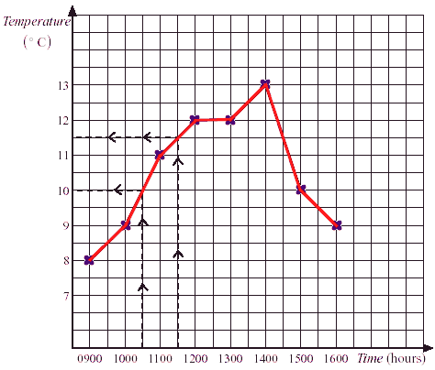

* **Find the sum of the data**

Example: What was the total number of days absent over the 6 years?

Answer: 3 + 4 + 7 + 7 + 9 + 2 = 32 days

Days absent

**5/30 Interpret information in tables**

* **Distance table**

Example: Find the distance between **Leeds** and **York**

Answer: 40miles

|  |
| --- |
| Hull |
| 100 | **Leeds** |
| 162 | 73 | Manchester |
| 110 | 60 | 65 | Sheffield |
| 63 | 40 | 118 | 95 | **York** |

* **Timetable**

Example: How long is the film?

Answer: 1.10 – 2.35 = 1h 25min = 85min

|  |  |
| --- | --- |
| 6.30am | Educational programme |
| 7.00 | Cartoons |
| 7.25 | News and weather |
| 8.00 | Wildlife programme |
| 9.00 | Children's programme |
| 11.30 | Music programme |
| 12.30pm | Sports programme |
| 1.00 | News and weather |
| 1.10 - 2.35pm | Film |

* **Table of results of goals scored**

Example: Did boys or girls score the most goals?

Answer: Boys: 6+3+3+6=18

Girls: 7+5=12

Boys scored the most goals

