Maths Key Skills Stage 2: Skill Check 13

Name: ___________________________________ Date: _______________ Class/Group: _______________________________

A: Place Value, Add and Subtract |  | B: Multiply, Divide and Fractions |  |  | C: Measure and Geometry
1. What is the missing number?  0 5 10 15 25 | 2:1 | 11. 4 x 10 = |  | 2:11 | 21. What units would you use to measure the capacity of a cup?  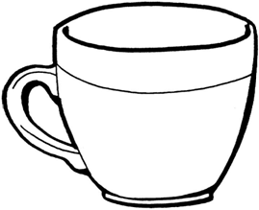  a. centimetres  b. grams  c. millilitres |  | 2:17
2. What is the value of the 8 in this number? 18 | 2:2 | 12. 8 ÷ 2 = |  | 2:11 |  |  | 2:17
3. Estimate the number labelled.  0  20  10 | 2:3 | 13. What symbol is missing?  12 ÷ 6 2 |  | 2:12 | 22. How many vertices does a cuboid have?  a. 6  b. 8  c. 12 |  | 2:24
4. Use <, > or = to make this correct:  52 24 | 2:4 | 14. What symbol is missing?  6 5 = 30 |  | 2:12 |  |  | 2:24
5. Write this number in numerals.  thirty eight | 2:5 | 15. Tick (✓) if true:  7 ÷ 8 = 8 ÷ 7 25 x 5 = 5 x 25 |  | 2:13 | 23. Name the shaded face on this cube. |  | 2:25
6. There are 18 sweets in a bag. Tom eats 7 of them. How many are left? | 2:6 | 16. £21 is shared between 3 people. How much does each person get? |  | 2:14 |  |  | 2:25
7. 11 + = 20 | 2:7 | 17. 3 cars each have 4 people in them. How many people are in the cars? |  | 2:14 | 24. Tick (✓) the shape that contains an obtuse angle. |  | 2:26
8. 53 - 37 = | 2:8 | 18. What fraction of the  strawberries are circled?  1  3 |  | 2:15 |  |  | 2:26
9. Is this true? Write ‘yes’ or ‘no’.  45 - 27 = 27 - 45 | 2:9 | 19. Shade in  3  4  of the shape. |  | 2:15 | 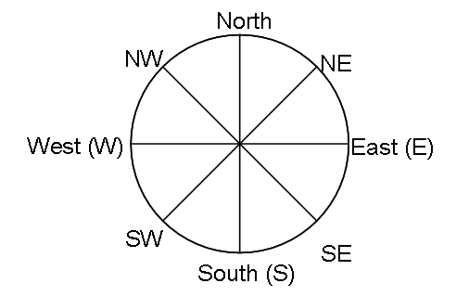  25. Ben is facing East.  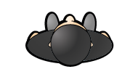  What direction will  he be facing after  turning through 1  right-angle anticlockwise? |  | 2:28
10. Use 17 + 25 = 42 to help find:  42 - 17 = | 2:10 | 20. What is of 20? |  | 2:16 |  |  | 2:28
Total (A) |  | Total (B) |  |  | Total (C)
Test Total (A+B+C) |  | R (0-9) | Y (10-19) |  |  | G (20-25)

