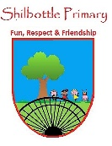

**Languages - Year 3 – Spring 1 – Food glorious food.**

**Books**

**Skills**

**Vocabulary Meaning**

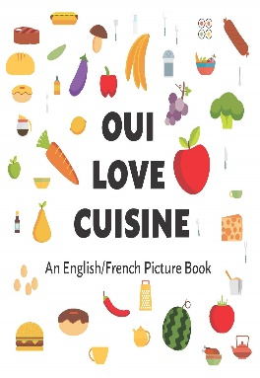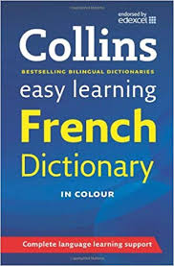

**clair**

I can listen attentively to spoken language and show understanding by joining in and responding.

Appreciate stories, songs, poems and rhymes in the language

Develop accurate pronunciation.

light/pale

**fraises**

strawberries

large/big

**grand**

I like

**j’aime**

**Knowledge**

I don’t like

**je n’aime pas**

I would like

**je voudrais**

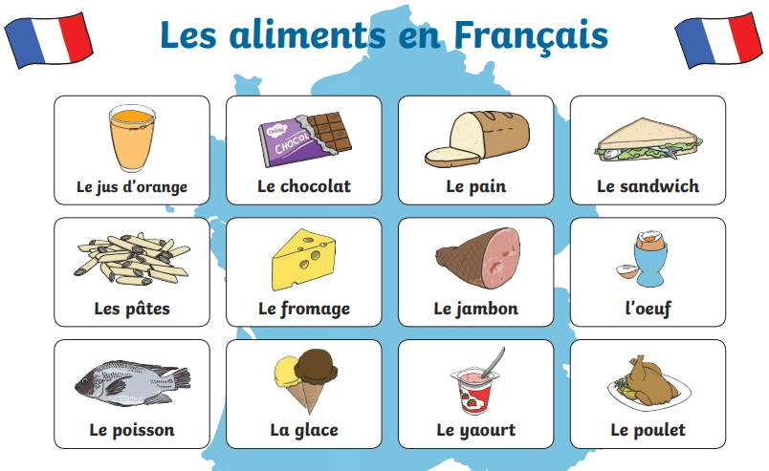

small

**petit**

pears

**poires**

apple

**pomme**

**sucette**

lollipop

bright

**vif**

**voila**

here you go

**What I should be able to do and know now.**

**What I will know and be able to do at the end of the topic.**

**Growth Mindset Strategies.**

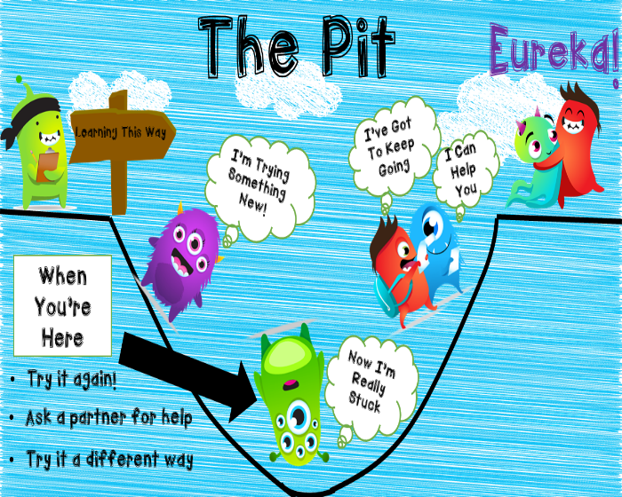

**Knowledge**

|To follow classroom instructions in French.

Vocabulary to develop an ability to understand new words in the context of clothing.

Develop accurate pronunciation and intonation so that others understand when I am reading aloud or using familiar words or phrases.

**Skills**

To listen and respond to instructions.

To demonstrate my understanding with actions.

|To listen and copy pronunciation of colour words accurately.

To ask and answer what I like and don’t like.

To recognise masculine and feminine clothing nouns.

**Knowledge**

I recognise French vocabulary that is associated with greetings.

I use greetings to greet my friends during our activities.

I use the French numbers to tell the listener how many I have during a particular activity.

**Skills**

I can respond in writing and speech using the French language to answer questions.

I can listen and respond to French vocabulary that is linked to the topic.

**What I will be learning.**

I can follow a familiar story in French.

I can use determiners for identifying quantities in making polite requests.

I can give a preference for or against things.

I can describe the colour of an object by modifying adjectives.