Maths Key Skills Stage 1: Skill Check 14

Name: ___________________________________ Date: _______________ Class/Group: _______________________________

A: Number and Place Value |  | B: Fractions and Measure |  |  | C: Measure and Geometry
1. What is the missing number?  22 23 24 26 | 1:1 | 11. Circle ½ of the bricks. |  | 1:11 | 16. When putting on socks and shoes, I put my socks on a. after  b. first  c. last |  | 1:16
2. What is the missing number?  4 6 8 10 | 1:2
3. What number is one more than 59? | 1:3 | 12. What fraction of the counters are black? |  | 1:12 | 17. What is the last month of the year? a. January  b. December  c. November |  | 1:17
4. What number is labelled?  5  10 | 1:4
5. Write this number in words:  8 | 1:5 | 13. Circle the tallest tower. |  | 1:13 | 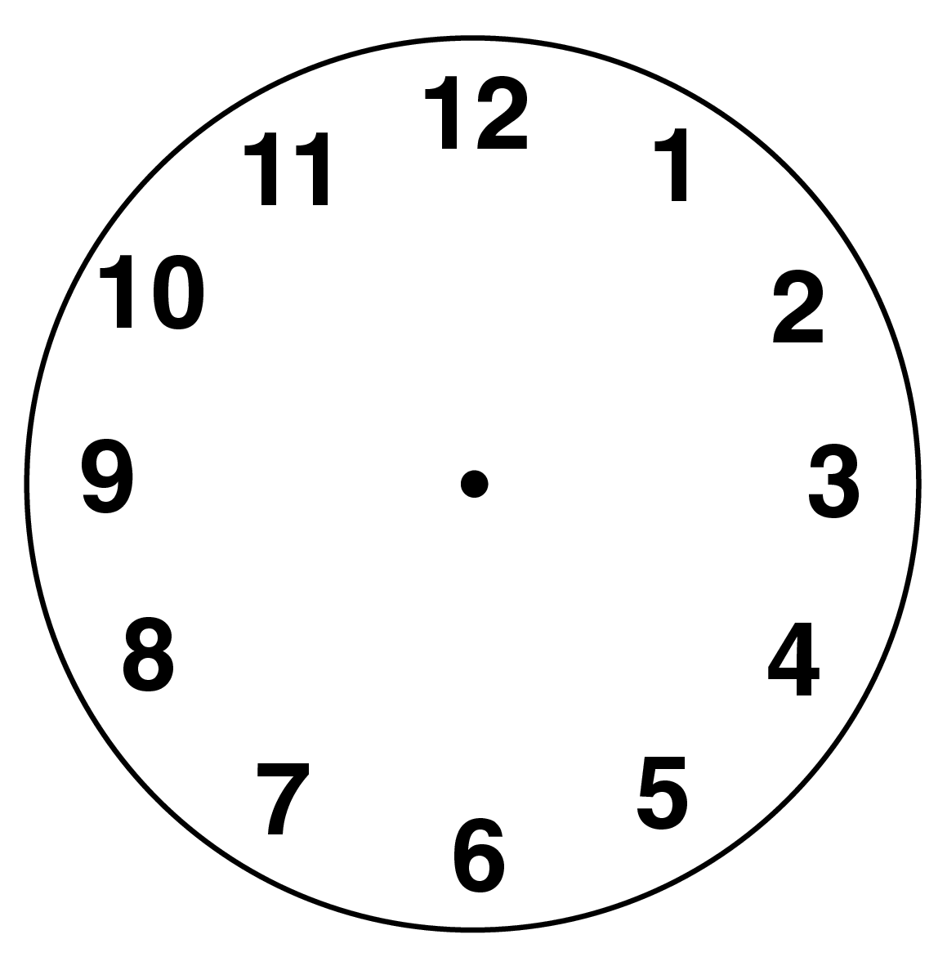  18. What time does  this clock show? |  | 1:18
6. What symbol is missing?  7 + 8 15 | 1:6
7. What is the missing number?  11 + = 20 | 1:7 | 14. How much water is in the bowl?  200ml  100ml |  | 1:14 | 19. Tick the sphere.    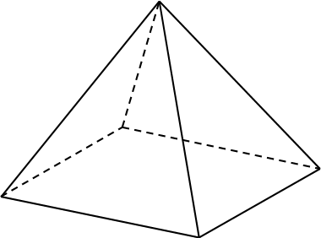 |  | 1:19
8. 14 + 9 = | 1:8
9. There are 13 people on a bus. 4 get on. How many people are there now? | 1:9 | 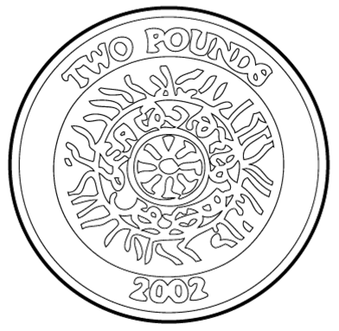  15. How much altogether? |  | 1:15 | 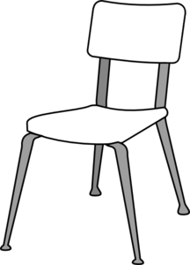  20. The teddy bear is:  a. on the chair.  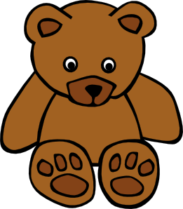  b. behind the chair.  c. in front of the chair. |  | 1:20
10. 6 toys are shared by 3 children. How many toys do they get each? | 1:10
Total (A) |  | Total (B) |  |  | Total (C)
Test Total (A+B+C) |  | R (0-7) | Y (8-15) |  |  | G (16-20)

