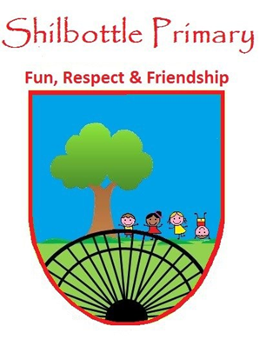
Year 4 Spelling List – Autumn 1

Spelling lists for this term are given below. Each week children will have 6 spellings following a spelling rule and 4 spellings from the expected to know lower KS2 words. Children will be tested on these spellings on a Friday in class and will also be given 2 ‘unknown’ spellings on the test which will follow the spelling rule for that week.

Week 2  Test date 17/9/21 | Week 3  Test date 24/9/21 | Week 4  Test date 01/10/21 | Week 5  Test date 08/10/21
Spelling rule  Adding the prefix mis-, un-, in-, and dis-  misbehave  inactive  unfair  mismatch  distrust  inhuman  Lower KS2 spellings  accidentally  actual  address  answer | Spelling rule  Adding the prefix mis-, un-, in-, and dis-  unkind  misspell  misunderstand  disagree  disappear  unhappy  Lower KS2 spellings  appear  arrive  believe  bicycle | Spelling rule  Words ending zhuh spelt -sure  treasure  measure  leisure  enclosure  pleasure  closure  Lower KS2 spellings  breath  breathe  build  busy | Spelling rule  Words ending zhuh spelt -sure  picture  treasured  measurement  measuring  leisurely  capture  Lower KS2 spellings  calendar  centre  caught  century
Week 6  Test date 15/10/21 | Week 7  Test Date 22/10/21 | Helping your child to practice can be done by testing them throughout the week or by using a range of activities such as pyramid spellings, rainbow writing, forwards and backwards writing.  A set of cards using these activities will be sent home at the start of the year.
Spelling rule  Short u sound spelt ou  trouble  enough  toughest  rougher  young  country  Lower KS2 spellings  certain  circle  complete  consider | Spelling rule  Adding the prefix auto-  autopilot  autobiography  automatic  automobile  autograph  autocue  Lower KS2 spellings  continue  decide  describe  different

