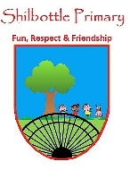
RE – 6 – Autumn 2 – The Christmas Story
Skills
- Begin to question key events.
- Interpret a situation from a photograph.
- Draw comparisons between different versions of the same story.
- Evaluate key parts of a story.
- Investigate different celebrations of the same event
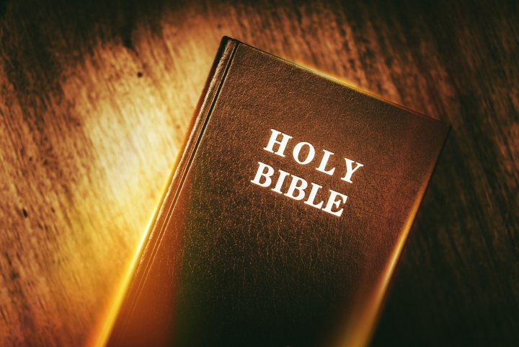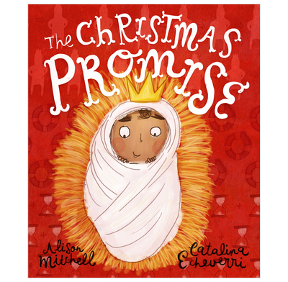
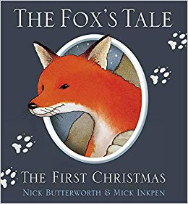
Books

Knowledge
- The idea that Jesus was laid in a manger, in an Inn, is significant to Christians as it is an indicator of His nature and purpose.
- It is believed King Herod ordered baby boys to be killed as it threatened his position.
- Know that there are similarities and differences between the nativity story told by Matthew and Luke in the Gospels
- In the Gospel according to St Luke, value is given to undervalued people in Biblical times.
- Matthew’s account of the Christmas Story focusses on power.
- Advent is the time of waiting for the arrival of Christmas, the coming of Jesus to earth just over 2000 years ago.
- Pagans used to worship trees in the forest and this was adopted by the church and associated with a sign of the everlasting life of God.
- Santa Claus giving presents comes from the concept of a gift-giver. Church history and folklore merged St Nicholas with the character Father Christmas to create Santa Claus.
- St Lucia is a symbol of light and reminds Swedish people that after December the long nights get shorter.
Vocabulary | Meaning
census | An official count or survey, especially of a population.
manger | A long trough from which horses or cattle feed.
Magi | (PLURAL of magus) members of a priestly caste of ancient Persia.
frankincense | An aromatic gum resin obtained from an African tree and burnt as incense.
myrrh | A fragrant gum resin obtained from trees and used in perfumery, medicines and incense.
interpretation | The action of explaining the meaning of something.
St Matthew | One of the twelve apostles of Jesus.
St Luke | Flourished in the 1st century and the author of one of the Gospels.
Gospels | The teaching or revelation of Christ.
Advent | Comes from the Latin word ‘adventus’ and means arrival.
Pagans | A person holding religious beliefs other than those of the main world religions.
mistletoe | A leathery-leaved plant which grows on apple, oak and other broadleaf trees
literally | Words are true exactly as they are.
metaphorically | Words being used figuratively rather than literally.
Key People
Mary St Matthew
Joseph St Luke
Jesus Father Christmas
Shepherds St Lucia

Concept Links
What I will know and be able to do at the end of the topic.
What I should be able to do and know now.

Knowledge
Know that there are 4 Gospels in the Bible.
Know that Matthew, Mark, Luke and John wrote the Gospels.
Know that Bethlehem is an important religious site.
Know the role of the key figures in the Christmas Story.
Christians believe in Jesus and Jesus was the son of Mary.
Know the importance of Christmas to Christians.
Recognise that signs and symbols tell Christians about their past and inform their faith.
Skills
Ask questions about religion.
Make comparisons between different people’s emotions throughout the story.
Understand the Christmas story from different viewpoints.
Interpret religious ideas from art.

Knowledge
- Jesus being laid in a manger is significant because …
Jesus being laid in a manger is significant, but …
Jesus being laid in a manger is significant, so …
- King Herod killed baby boys because …
King Herod killed baby boys, but …
King Herod killed baby boys, so …
- According to the Gospel of Matthew, an angel visited Jospeh to tell him Jesus was the son of the Holy Spirit because …
According to the Gospel of Matthew, an angel visited Jospeh to tell him Jesus was the son of the Holy Spirit, but …
According to the Gospel of Matthew, an angel visited Jospeh to tell him Jesus was the son of the Holy Spirit, so …
- Matthew and Luke’s version of the Christmas story are different because …
Matthew and Luke’s version of the Christmas story are different, but …
Matthew and Luke’s version of the Christmas story are different, so …
- Advent is important to Christians because …
Advent is important to Christians, but …
Advent is important to Christians, so …
- Not all Christians celebrate Christmas in the same way because …
Not all Christians celebrate Christmas in the same way, but …
Not all Christians celebrate Christmas in the same way, so …

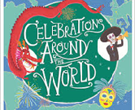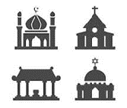

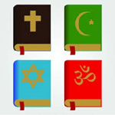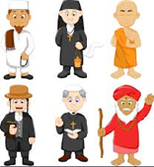

Places of Worship
Celebrations and festivals.

Significant People
Religious Books and Music.

What I will be learning

- Be able to recall the Christmas Story.
- Be able to explain what interpretation means.
- Be able to investigate similarities and differences between Matthew and Luke’s version of the nativity.
- Be able to explain the key truth within both versions of The Christmas Story in the Gospels.
- Be able to explain the meaning of advent and how Christians prepare.
- Be able to explain how Christians in different countries celebrate Christmas differently.

