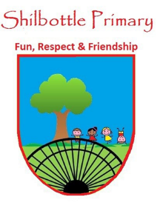
Year 5 Spelling List – Spring 1
Dear Parents/Carers,
Below is a copy of the spellings which will be tested this half term. The spellings will be a mix of a general spelling rule each week as well as some statutory UKS2 spellings.
Spelling homework should be handed in by Thursday each week. The children are expected to copy out the 10 spelling words and then write a sentence for each word which shows their understanding of the word meanings. Please note - This may not be enough to learn the spellings completely, it is expected that the children will carry out further practice at home of the spellings, in preparation for the spelling test on Friday.

Week 1  Test date: 13/01/2023 | Week 2  Test date: 20/01/2023 | Week 3  Test date: 27/01/2023
Spelling rule  Words ending in shus spely -cious  spacious  vicious  precious  suspicious  conscious  delicious  Year 5 and 6 spellings  forty  frequently  government  guarantee | Spelling rule  Words ending in shus spelt -tious  scrumptious  cautious  infectious  ambitious  superstitious  nutritious  Year 5 and 6 spellings  harass  hindrance  identify  immediate | Spelling rule  Words ending in shul spelt –cial or -tial  official  special  social  artificial  financial  essential  Year 5 and 6 spellings  Immediately  Individual  Interfere  interrupt
Week 4  Test date: 03/02/2023 | Week 5  Test date: 10/02/2023 | Week 6  Test date: 17/02/2023
Spelling rule  Words with silent letter b  doubt  limb  climb  lamb  subtle  bomb  Year 5 and 6 spellings  language  leisure  lightning  marvellous | Spelling rule  UKS2 statutory words  category  familiar  equipment  aggressive  attached  definite  language  criticise  explanation  apparent | Spelling rule  Words from the term  conscious  financial  nutritious  climb  government  ambitious  delicious  artificial  immediately  subtle

