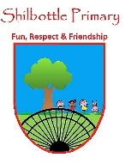
RE - Year 1 – spring 1 and 2 – Sharing special books
00
Skills
Ask and enquire.
Recall and remember.
Make links to other areas of learning.
Talk about my learning.
Use vocabulary related to religion.
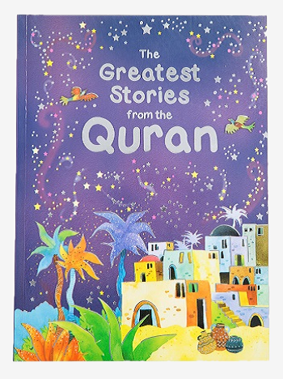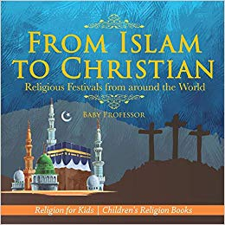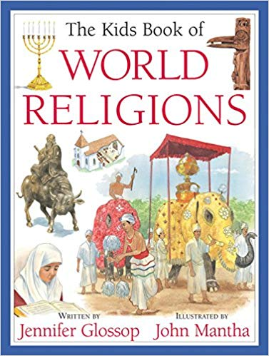
Books

Knowledge
Discuss experiences of special books
Find out about the story of Abraham from the Jewish Torah.
Find out about the story of Noah and the Ark from the Christian Bible.
Understand why the story of Abraham is important to the Muslim religion.

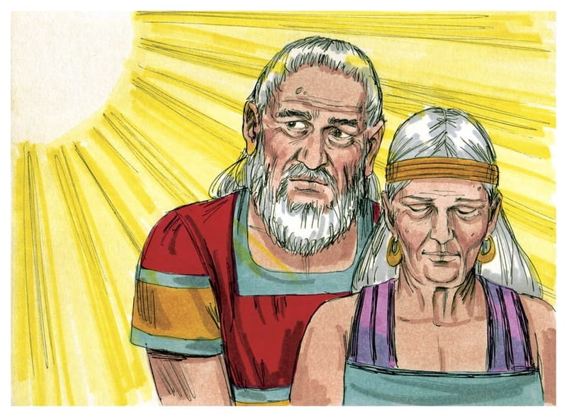
Vocabulary | Meaning
Bible | The Christian holy book.
Qu’ran | The holy book of the Muslim religion.
religion | The belief and worship of a God.
sacred | Something that is linked with God.
special | Made for a particular purpose. Something that means a lot to someone.
Torah | The holy book of the Jewish religion.
yad | A pointer used to read the Torah.

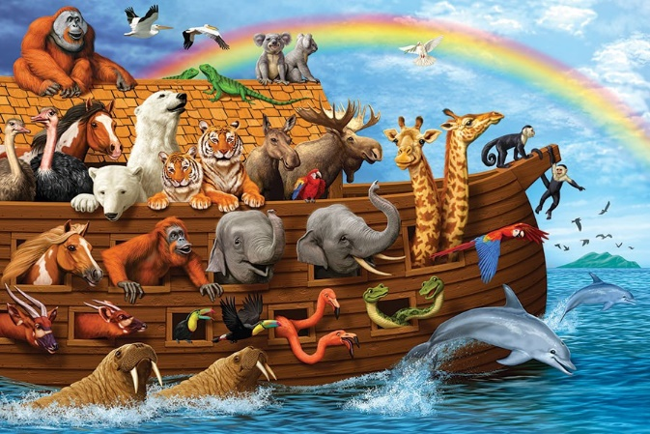

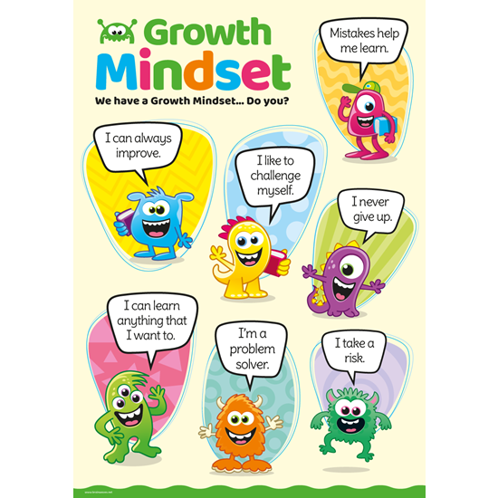
Bib
What I will know and be able to do at the end of the topic.
Growth Mindset Strategies

What I should be able to do and know now.
Knowledge
Which books are important to you? Children can explain a book that is special to them, why it is special and where they keep it.
Do you know any special books for different religions? - The Torah, The Bible and The Qur’an.
What religion uses the Torah? – The Torah is the Holy Book of the Jewish religion and is read with a yad.
Who uses a Bible? The Bible is the holy book of the Christian religion. Some Bibles are mass produced and some are more decorative.
What is the holy book of the Muslim religion and why is it so special? – The Qu’ran is the holy book of the Muslim religion. Muslims believe the word of Allah is sacred so the Qu’ran is sacred because it contains the word of God.
Skills –
Can you remember any special stories from the Bible?
How did each religion think the world was created?

Knowledge
I know who God and Jesus are.

Skills
I can answer ‘how’ and ‘why’ questions about my experiences and in response to stories or events.

I can use past form accurately when talking about events that have happened.

I know about similarities and differences between myself and others, and among families, communities and traditions.

What I will be learning

- I can understand that different people have special books.
- That religious books need to be treated with respect.
- Why the story of Abraham is important to the Jewish religion.
- Why the story of Noah and the ark is an important bible story.
- Why the story of Mohammed is important to the Muslim religion.

