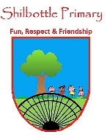
RE – Y5 – autumn – What is the Bible and where did it come from?
Skills
Children can respond to questions about the Bible
Children know that the Bible is a collection of writings from many different times
Children can explain why they find a section of the Bible interesting
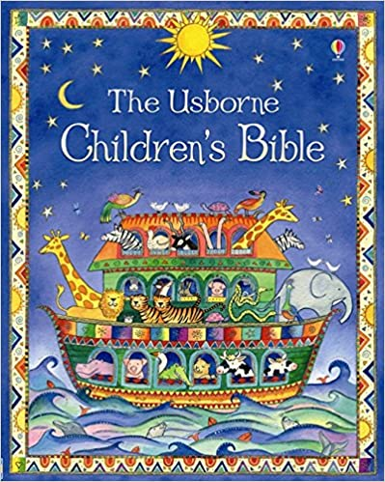
Books

Vocabulary | Meaning
Bible | The Christian scriptures, consisting of the Old and New Testaments.
books of the Bible | The Bible is a collection of sacred texts or scriptures. Varying parts of the Bible are considered to be a product of divine inspiration and a record of the relationship between God and humans by Christians
Christians | People who believe in the religion of Christianity.
Jesus | The name of a man who Christians believe was the son of God.
saviour | A person who saves someone who is in difficulty.
Knowledge
Children know that the Christian Bible is the best-selling book of all time
Children can ask questions about the Bible
Children know that the material in the Bible predates the written text
Children know how to differentiate dates before and after Jesus
Children can identify some of the different literary genres in the Bible
Children know that writers write in different ways for different purposes
Children know that there are many different translations of the Bible
Children can explain why the Bible is still relevant to Christians today
Children are able to evaluate and discuss Bible verses and what they mean
Children understand the difference between literacy and figurative truth

Can children reflect on their own emotions in relation to a story?
Key People and facts

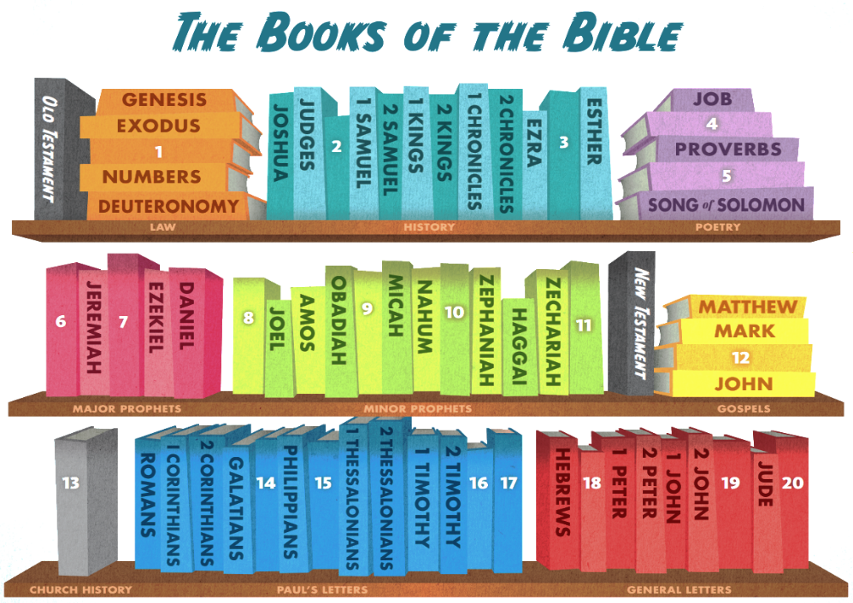

Growth Mindset Strategies
What I will know and be able to do at the end of the topic.
What I should be able to do and know now.

Understand the difference between a FIXED
mindset and a GROWTH mindset.
Be Curious; Be courageous.
Challenge yourself. Ask, ‘What could I do
differently next time?’
Give everything your best effort and
persevere.
Practice; Practice; Practice.

Knowledge

Children know that the Christian Bible is the best-selling book of all time because …
Children know that the Christian Bible is the best-selling book of all time but …
Children know that the Christian Bible is the best-selling book of all time so …

Children can ask questions about the Bible because …
Children can ask questions about the Bible but …
Children can ask questions about the Bible so …
Skills
Children can respond to questions about the Bible
Children know that the Bible is a collection of writings from many different times
Children can explain why they find a section of the Bible interesting

Knowledge
- Why Palm Sunday is called Palm Sunday and the events that took place this day.
- Learn the story of Jesus’ crucifixion and resurrection.
- Understand how people felt in the story by exploring it from different viewpoints of the people involved.
- Name people who were involved in Jesus’ crucifixion and the role they played.
Skills
- To be able to understand the story from different points of view.
- To retell a story accurately.
- To use music to express religious ideas.
- To use art to express religious ideas.

What I will be learning

- To ask and respond to questions about the Bible.
- To learn about the history of the Bible and some of its features.
- To investigate the contents of the Bible.
- To learn about different translations of the Bible and what it means for Christians today.
- To understand the difference between literal and symbolic truth and to reflect on personal emotions.

