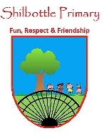
History – Year 3 – spring 1 – The Ancient Greeks
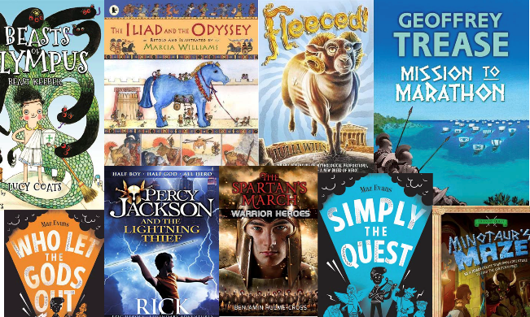
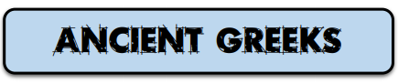
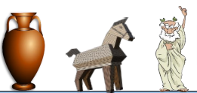
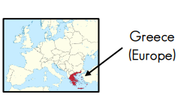
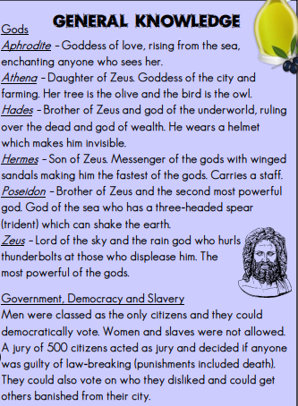

Books

Knowledge

Skills
Ask and enquire using books, photographs and technology.
Develop chronologically secure knowledge of world history.
Note connections, contrasts and trends over time.
Construct informed response that involve relevant historical terms.
Vocabulary | Meaning
acropolis | a large hill where city residents sought shelter and safety in times of war. Also, a meeting place for discussing issues.
ampitheatre | an outdoor theatre with seats on all sides where singing, dancing and even sacrificing took place.
Archimedes | a mathematician and philosopher who found  a way of measuring water by placing an  object in it and seeing how far it rose  (hydrostatics). He jumped out of the bath  and shouted ‘Eureka!’ meaning ‘I found it!’
chiton | a single sheet used as clothing wrapped around the body.
democracy | a system of government in which citizens are able to vote in order to make decisions.
Hippocrates | a famous doctor known as the ‘father of  Western medicine’. Doctors today still take  the ‘Hippocratic Oath’ promising to be good  at their job and do their best for patients.
Olympics | athletes competing against each other. Began in Olympia and included religious festivals in honour of Zeus.
Parthenon | a former temple on the Athenian Acropolis dedicated to the goddess Athena.
philosophy | the practice of asking big questions with no clear/single answer. It means the ‘love of wisdom’
pyxis | a cylindrical box with a separate lid used to store  trinkets, ornaments or cosmetics
Trojan Horse | Wooden horse constructed by Greeks to obtain entry into the city of Troy. Soldiers hid inside and then sprang out!
vase | Pots made on a potters’ wheel often painted with aspects of daily life from which historians have learned from.

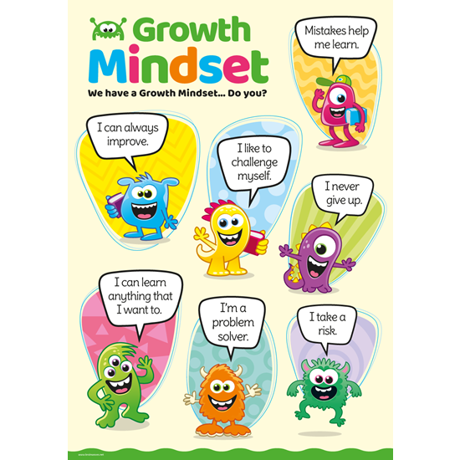
What I will know and be able to do at the end of the topic.
Growth Mindset Strategies

What I should be able to do and know now.
Greece is in the continent of E__________. I can point to this on a map of the world.

I know that a government system that allows people to vote in order to make decisions is called a d_____________.

I can explain what a Trojan Horse is and what the Ancient Greeks used it for.

The Ancient Greeks had several Gods. I can name them and tell you what they were the God of.

The Greek Empire was established to _____________.

Ask me to write like an Ancient Greek.

I know that artefacts help us work out what life was like in the past.

770BC First Greek alphabet created.

776BC First Olympic games.

600BC First Greek coins are used.

500BC Democracy used in Athens.

146BC Greece becomes part of the Roman Empire.
Knowledge
Where to find the Europe on a map.
What ancient means.
I know other periods of History and other significant figures from the past.
Name a significant person from Ancient Greece.
Know what a non-fiction book is and how it can help our learning.

Skills
Place events in chronological [date] order.
Ask questions about the past.
Know some ways we can find out about the past.
Use vocabulary related to the passing of time – before, after, a long time ago, past.
Read and recall non-fiction text.

What I will be learning

To know where and when Ancient Greek civilisation existed.
To know some significant events for the history of Ancient Greece.
To understand about the Greek Empire including how it was established and maintained.
To understand the religious beliefs of the Ancient Greek people.
To have knowledge of the Ancient Greek writing system and know some well-known Greek writers and stories.

