Maths Key Skills Stage 4: Skill Check 3

Name: ___________________________________ Date: _______________ Class/Group: _______________________________

A: Place Value, Add and Subtract |  | B: Multiply, Divide and Fractions |  |  | C: Measure, Geometry and Statistics
1. What is the missing number?  18 30 36 42 | 4:1 | 11. 9 x 11 = |  | 4:9 | 21. What is the area of this shape?  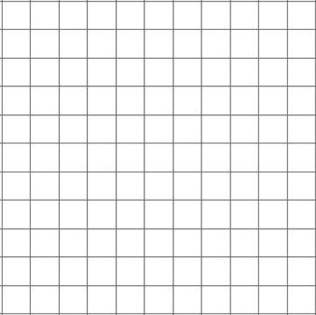  1cm |  | 4:20
2. What is the missing number?  4,000 5,000 6,000 8,000 | 4:1 | 12. Circle the sum that is the same as 22 x 5: 2 x 5 x 11 2 x 3 x 22 |  | 4:10 |  |  | 4:20
3. Round this number to the nearest 100: 2,167 | 4:2 | 13. 356 x 3 = |  | 4:11 | 22. Circle the name that describes the biggest angle.  Right Obtuse Acute  angle angle angle |  | 4:24
4. What is 1,000 less than 1,465? | 4:2 | 14. To work out 47 x 6 you could do:  x 6 + 7 x  1  4 |  | 4:12 |  |  | 4:24
5. What is 6 less than 2? | 4:3 | 15. Circle the equivalent fraction to .  3  12  5  16  6  20 |  | 4:13 | 23. To transform shape A onto B:  Translate A  A  B  units to  the . |  | 4:27
6. What is the value of the 7 in this number? 2,789 | 4:4 | 16. Complete  37  100  38  100  39  100  the sequence: |  | 4:14 |  |  | 4:27
7. Write the number 90 in Roman numerals. | 4:5 | 17.  1  2  3  7  5  7  + |  | 4:15 | 24. The distance time graph shows a trip to the shops. The return journey takes 20 minutes. Show this.  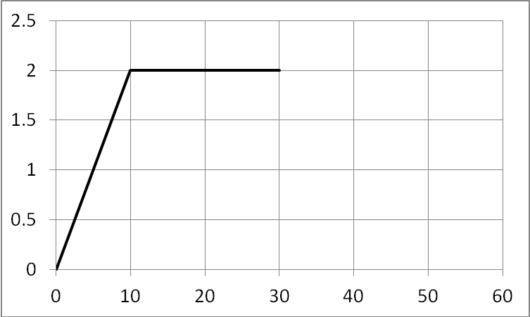  Distance (km)  Time (minutes)  25. How long did the person spend at the shops? |  | 4:29  4:30
8. 1,235 - 624 = | 4:6 | 18. Write as a decimal number. |  | 4:16 |  |  | 4:29  4:30
9. Write the sum to check 3,128 + 854 = 3,982: 3,982 854 3,182 | 4:7 | 19. 8 ÷ 10 = |  | 4:17 |  |  | 4:29  4:30
10. I have £5. I spend £1.50 then £2.45. How much do I have left? | 4:8 | 20. Label 4.8cm on the ruler section:  4  5  4.5 |  | 4:18 |  |  | 4:29  4:30
Total (A) |  | Total (B) |  |  | Total (C)
Test Total (A+B+C) |  | R (0-9) | Y (10-19) |  |  | G (20-25)

