History– Year 1 and 2 – Toys Past and Present

Books

Vocabulary  Skills  Ask questions to find out information.  Develop an awareness of the past.  Place events in chronological order.  Ask and answer questions.  Use vocabulary related to the passing of time.  Know some ways we find out about the past.  Knowledge  To be able to describe the characteristics of toys.  To find out what toys our parents and grandparents played with.  To find out what toys were like at different times in the past  To be able to identify toys that are old and toys that are new.  To be able to describe how toys are different and how they are the same.  To be able to create a toy museum. | Meaning
decade | A period of 10 years.
Etch a Sketch | A plastic toy used for drawing.
lead | A type of metal.
Lego | Plastic construction blocks used for building.
Meccano | A model construction toy made of metal strips, plates, wheels, axles and gears and plastic parts that are connected using nuts and bolts.
modern | From present times.
museum | A building which has old objects stored and exhibited.
old-fashioned | From the past, a long time ago.
Rubiks cube | A plastic cube puzzle covered with multicoloured squares,
Space hopper | A large rubber ball with handles that you sit on and bounce.

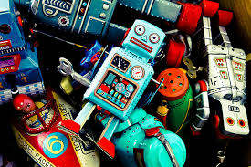

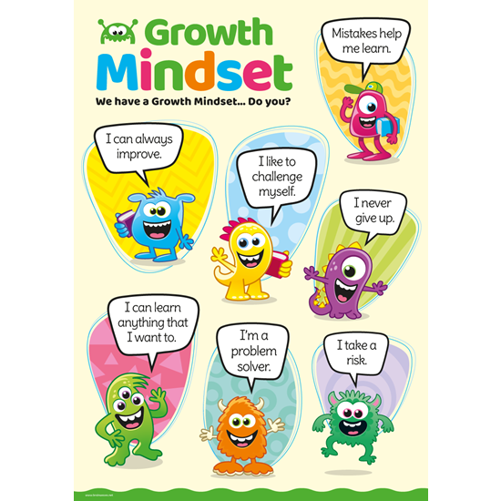
What I will know and be able to do at the end of the topic.
Growth Mindset Strategies

What I should be able to do and know now.
Knowledge
What is a decade? It is a period of 10 years.
Can you name which toys were popular in the 1950s? Matchbox toys, pedal cars, hula hoops, playdoh, Mr Potato Head, Frisbees.
What decade did computer games become popular? – In the 1980s.
How are new toys different from toys in the past? – The material they are made of, new toys are more modern and colourful.
Can you name any different categories of toys? Moving toys, Dolls, models and stuffed animals, Puzzles and games, Outdoor toys and Building toys.
Skills –
Using your knowledge from science, what properties should the materials have that are used for toys?
What materials are often used to make toys?

Knowledge
I can talk about past and present events in my life and in the lives of family members.

Skills
I can answer ‘how’ and ‘why’ questions about my experiences and in response to stories or events.
I can use past, present and future forms accurately when talking about events that have happened or are to happen in the future.

What I will be learning

- How to describe toys by their characteristics using appropriate vocabulary.
- To make suggestions for how they
could find out about what toys were like in the
past.
- Can identify some similarities and differences between toys in the past and toys today and ask questions about them.
- How to understand what a decade is and order them and the associated toys chronologically.
- How to sort old and new toys into categories.
- That some of the types of toys they play with were played with by children in the past too.

