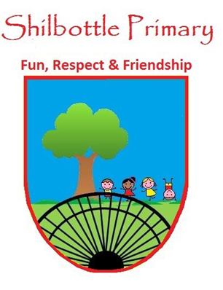
Dear parents/carers,
Below is a copy of the spellings which will be tested this half term. There will be five spellings from the spelling rule being learned and five spellings from the Y5 and 6 statutory spellings. A copy of these words will also be available from the school website should you need to replace them. Many thanks for your continued support.

Week 1  Test Date: 5 November |  | Week 2  Test Date: 12 November |  | Week 3  Test Date: 19 November
Spelling Rule:  1. admit  2. permit  3. prefer  4. regret  5. forgot | Statutory:  1. definite  2. desperate  3. determined  4. develop  5. dictionary | Spelling Rule:  1. profession  2. sufficient  3. correspond  4. apparently  5. opportunity | Statutory:  1. disastrous  2. embarrass  3. environment  4. equip  5. equipped | Spelling Rule:  1. busy  2. happy  3. heavy  4. beauty  5. mystery | Statutory:  1. equipment  2. especially  3. exaggerate  4. excellent  5. existence
Spelling Rule: Suffixes;  A suffix is a letter or group of letters that can be added to the end of a word to change its meaning.  Some suffixes can begin with a vowel sound and some begin with a consonant.  Children will be given the root word to learn and must apply the correct spelling rule in the test.  A syllable is a beat in a word. Words can have one or more syllables.  1. When we add suffixes beginning with a vowel to words of one syllable that end in one vowel letter and one consonant letter, we double the final consonant. This keeps the vowel in the root word short.  2. Words with more than one syllable that end in just one vowel letter and one consonant letter (where the stress is on the final syllable), we double the final consonant when adding suffixes beginning with a vowel (like –ed) |  | Spelling Rule:  Orange Words; Proceed with Caution …  These are common words that even some adults find tricky to spell. These words make up the Year5/6 statutory spellings. |  | Spelling Rule: Suffixes  Swap, Double or Drop  Root words that end in a consonant + ‘y’  There are lots of different suffixes we can add to these root words whether they atart with a consonant (-ness) or a vowel (-er).  Before adding a suffix beginning with a consonant or a vowel, to a root word ending in one consonant + ‘ding a suffix beginning with a consonant or a vowel, to a root word ending in one consonant + ‘y’, we swap the ‘y’ for an ‘i’.  HOWEVER, the suffix ‘-ing’ begins with the vowel letter ‘i’, so we don’t change the ‘y’ to an ‘i’ when we add ‘-ing’ otherwise we would have double ‘i’ in some words ending in a consonant plus ‘y’.
Week 4  Test Date: 26 November |  | Week 5  Test Date: 3 December |  | Week 6  Test Date: 10 December
Spelling Rule:  1. queue  2. hindrance  3. mischievous  4. vehicle  5. guarantee | Statutory:  1. explanation  2. familiar  3. foreign  4. forty  5. frequently | Spelling Rule:  1. direction  2. explanation  3. ancient  4. delicious  5. especially | Statutory:  1. disastrous  2. controversy  3. appreciate  4. committee  5. convenience | Spelling Rule:  1. | Statutory:  1.
Spelling Rule: Orange Words; Proceed with Caution …  These are common words that even some adults find tricky to spell. These words make up the Year5/6 statutory spellings. |  | Spelling Rule: The sh sound spelt ti or ci.  Roots Words ending in t or te use ti to make the sh sound in longer words (act becomes action)  Root Words ending in c, cs or ce use ci to make the sh sound in longer words (space becomes spacious) |  | Spelling Rule:  This week, children will be tested on a mix of words and spelling rules from the previous week’s spellings.
Week 7 – 17TH December - It’s CHRISTMAS …

All spelling tests will take place on a Friday, unless other school events mean it needs to be changed.

Spelling Rules: Children will learn a spelling rule to help them spell longer words correctly. To ensure children have learned the rule, their spelling rule words will be the root word (a basic word with no prefix or suffix added to it). During the spelling test, children will have to add the given prefix or suffix to the root word ensuring they have followed the rule studied.

Sometimes, the spelling rule will be a focus on Orange Words (Statutory words to be learned by the end of Y5/6). Although, usually, no spelling rule applies to these words, the week’s focus will be on different ways to remember how to spell these words correctly. Some words will be repeated over the year to consolidate the learning of the word.

Statutory Words (Orange Words): These are words that some adults find difficult to spell and they seldom follow a simple spelling rule. These are, generally, words that just have to be learned and remembered. However, there are different strategies that may help with the learning of these words. I have given a few examples below.

If you have any questions then please get in touch.
Thank you
MrP

Helping your child.

One method of helping your child learn their spelling is
‘Look, cover, write, check’
Children look at a word and sound it out, cover it, practice writing it and then check it.
If you wish to challenge your child even further you could ask them to say a sentence using the word or even write a sentence and then try to improve it.

Other ways to help learn spellings:
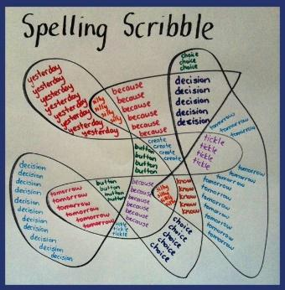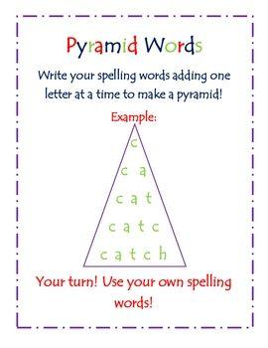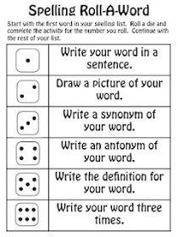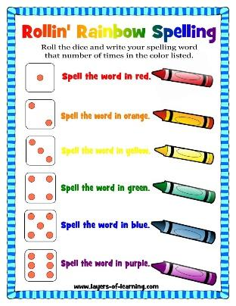

Memory Strategies:
Syllables: Listen to how many syllables there are and break the word into smaller chunks to remember. September = Sep – tem – ber (clap them out if it helps)
Root words: Find the root word of the longer word. Smiling = smile + ing
Analogy: Use words that you already know to help spelling. Would, Should, Could
Mnemonic: Make up a sentence to help remember the word:
Caught = Can An Ugly Goat Have Teeth

SPELLING HOMEWORK: All weekly spelling words are on LITERACY PLANET for children to practice as part of their homework.

