Science – Y5 – Spring 2 – Properties and changes in materials
Knowledge
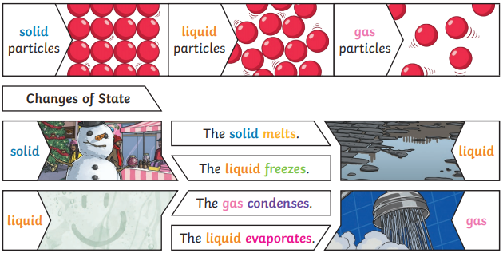
Skills
Children can interpret the results of their tests and use them to answer questions.
children plan a fair test to answer a question.

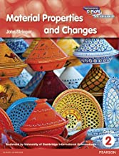
Books

Vocabulary | Meaning
condensing | When a gas such as water vapour cools and turns into a liquid.
conductor | A material that electricity or heat can easily travel through.
evaporating | When a liquid turns into a gas or vapour.
freezing | When a liquid cools and turns into a solid.
gases | One of three states of matter. |Gas particles are further apart than solid or liquid.
insulator | An insulator is a material that does not let heat or electricity pass through them.
liquids | This state of matter can flow and take up the shape of the container that it is poured into.
melting | The process of heating a solid unitl it changes into liquid.
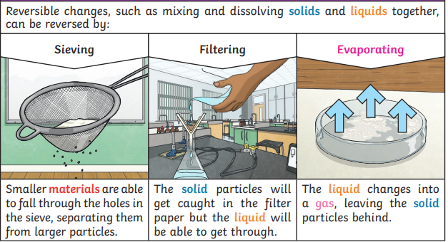

Growth Mindset Strategies
What I will know and be able to do at the end of the topic.
What I should be able to do and know now.

Knowledge
I know that some materials when mixed together can be useful because …
I know that some materials when mixed together can be useful but …
I know that some materials when mixed together can be useful so …

Burning materials can be extremely harmful to humans, animals and the environment because…
Burning materials can be extremely harmful to humans, animals and the environment but…
Burning materials can be extremely harmful to humans, animals and the environment so…

Skills:
Children can mix materials causing them to change.
Children know that heating and cooling materials can cause them to change.

Understand the difference between a FIXED
mindset and a GROWTH mindset.
Be Curious; Be courageous.
Challenge yourself. Ask, ‘What could I do
differently next time?’
Give everything your best effort and
persevere.
Practice; Practice; Practice.

What I will be learning
To know that some materials will dissolve in liquid to form a solution, and describe how to recover a substance from a solution.
That some changes of state and dissolving and mixing processes can be reversed through filtering, sieving and evaporating.
Explain that some changes form new materials, and that these changes are not usually reversible.

