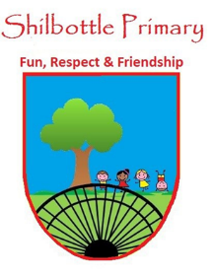
Year 5 Spelling List – Summer 1
Dear Parents/Carers,
Below is a copy of the spellings which will be tested this half term. The spellings will be a mix of a general spelling rule each week as well as some statutory UKS2 spellings.
Spelling homework should be handed in by Thursday each week. The children are expected to copy out the 10 spelling words and then write a sentence for each word which shows their understanding of the word meanings. Please note - This may not be enough to learn the spellings completely, it is expected that the children will carry out further practice at home of the spellings, in preparation for the spelling test on Friday.

Week 1  Test date: 21/04/2023 | Week 2  Test date: 28/04/2023 | Week 3  Test date: 5/05/2023
Spelling rule  Words ending in –ibly and -ably  incredibly  possibly  miserably  considerably  sensibly  reasonably  Year 5 and 6 spellings  queue  recognise  recommend  relevant | Spelling rule  Words ending in -ent  obedient  magnificent  efficient  different  innocent  decent  Year 5 and 6 spellings  restaurant  rhyme  rhythm  sacrifice | Spelling rule  Words ending in -ence  innocence  patience  independence  competence  evidence  difference  Year 5 and 6 spellings  secretary  shoulder  signature  sincere
Week 4  Test date: 12/05/2023 | Week 5  Test date: 19/05/2023 | Week 6  Test date: 26/05/2023
Spelling rule  The ee sound spelt ei  protein  caffeine  conceit  perceive  either  neither  Year 5 and 6 spellings  Sincerely  Soldier  Stomach  sufficient | Spelling rule  Near Homophones  affect  effect  accept  except  advice  advise  Year 5 and 6 spellings  suggest  symbol  system  temperature | Spelling rule  Words from the term  perceive  considerably  different  independence  evidence  sincerely  neither  effect  except  efficient

